

October University for

Modern Sciences and Arts

Faculty of Computer Science

Graduation Project 1

CS405x

Spring 2019

(Educational Video Game Using Unreal Engine)

Under Supervision of Dr. Ahmed Farouk

Name: Amr Ahmed Hassan

ID: 161377

**Abstract**

In Egypt, the educational process has not developed since

Table of Contents

Chapter 1: Introduction 5

1.1 Project Overview: 6

1.2 Objective: 6

1.3 Motivation: 7

1.4 History: 7

1.5 Thesis: 8

Chapter 2: Background & Previous work 9

2.1 Background 10

2.1.1 Game Design 10

2.1.2 Education 11

2.1.3 STEM 12

2.2 Previous Work 13

2.2.1 13

2.2.2 13

2.2.3 13

Chapter 3: Project planning & monitoring 14

3.1 Previous Work 15

References 16

Figures

Figure 1 How game gives hints to player through light and game environment 11

Figure 2 Tablet used by Egyptian students [1] 12

# Chapter 1: Introduction

## 1.1 Project Overview:

Education in Egypt has been developed drastically in the past 2 years, the integration of handheld devices and online learning are changing the way students read and interact to learn new topics, and as students have hard time grasping and understanding science topics, the developed countries have multiple new approaches and methods of educating students, like using video games in classrooms, aside from their ages, no student likes sitting at a desk for hours being told what to think and how to think it while looking at a textbook. In theory this project will change how we educate student here in Egypt. By giving them a narrative and story to follow. They will learn about chemistry, physics and history in a compelling and engaging game. All while developing cognitive and cooperative skills. Since video games has a huge share of almost every student’s day, we can use that time to help develop skills and educate them rather than let them waste it. The old system we have now does not help students in a practical way. Therefore, our game will show them scientific experiments that will make them to do research and other activities that require usage of cognitive skills, which in part will stimulate their eager to learn more and engage in the scientific field and learn about many interesting topics.

## 1.2 Objective:

To help students who have problems with the current educational methods or homeschoolers or even disabled students, that can’t move or go to school for any reason. Also deliver educational content in a more interesting ways so that the students will focus more and be eager to uncover the mysteries of the game. With cognitive and cooperative skills, they will be able to understand the concept of the game and advance through the story and will be eager to learn more and explore our virtual world.

## 1.3 Motivation:

Video games addiction recently became an official mental health disorder and recognized by health organizations such as WHO and they released an official manual for diagnosing this illness. In order to have more control over this phenomenon we need to provide a less addictive and productive games that will help the students have better understanding of the world and will help them understand the value of their time. The proposed game was fantasized by me as a child and was stuck on my mind till this day. So, this is my dream come true in a way, help people and have fun at the same time. Students waste a lot of their time playing video games that might also affect their school work badly and their lives if they were addicted to those games. Therefore, if you provide and alternative solution that will help them in their school work and be fun at the same time, it will be a much better option.

## 1.4 History:

Educational video games have been done before in many ways and the most successful ones were when games like current popular games were made, for example games like Fortnite, Pacman and other addictive games. Although that most video game players are above 18. Most games that you can find online are a bit childish and silly. So, the target audience for those games were ranging from 4-10 years old, while educational games for adults or teens are nonexistent. The education system itself In Egypt has been at a stalemate for a long time now and it needs development and restructuring to help students face the new challenges of life that comes with progress and new technologies that arise. The world is changing so fast that educational systems are lagging in so many ways. Computer classes in Egypt are outdated and not informative. History classes have you remembering names and events rather than knowing the impact of it. Historical events are taught through books and images rather than going to the monuments in which those events took place. Great historic figures are being described in the least informative ways. In the game those events will have much more impact on the students since they are interacting with it, and in some way living through it. The graphics and visuals will help the students retain the information that is being given to them.

## 1.5 Thesis:

In Chapter one we will discuss the idea and how to help students with video games. Chapter two we will give an idea about similar educational games and game design concepts. Chapter 3 will be about the non-functional and functional requirements which will be needed for the project and analysis.

# Chapter 2: Background & Previous work

## 2.1 Background

### 2.1.1 Game Design

Game design is a process in which the game designers look for the “fun” parts in a game and how to make the player like the game and interact with the game world, there are many ways to do that, By making the game extremely hard, like Dark Souls or Sekiro Shadows Die Twice, or by making the game feels like a movie and have emotional impact, like Beyond two souls and Heavy Rain. But what is common between all games is that they are all some sort of escape from reality. Players have the impressions of living different lives and engaging in exciting new worlds. The sense of accomplishment that games give them make them get attached to it if their real life is boring or empty at the time. Moreover, if they are stressed video games can help reduce that stress.

Game mechanics are the core of the game and what the player can do and how to interact with the world

One of the aspects of game design is the aesthetics. The aesthetics of any game is set by the game world design and the dynamics of the game. How the game feels and how it looks must take time out of the development cycle and considered equally important as other aspects of the game. Using lights, colors, or the player’s camera to guide the player to important parts or to focus on what we want him to see is used in a lot of successful games. For example, in Uncharted the player is guided through out the game by the camera, lights, colors, and structures to focus at what the game wants him/her to. Some games’ ideas are built around that concept. Some use color contrast and give important parts of the environment different color so that the player will notice them and progress through the game level. Light spots also give the player a clue where to look or what to look at. In some cases, the camera is moved so that the player would notice what the designer wants to show. But the difference between a good game and a bad one is how that technique is implemented.

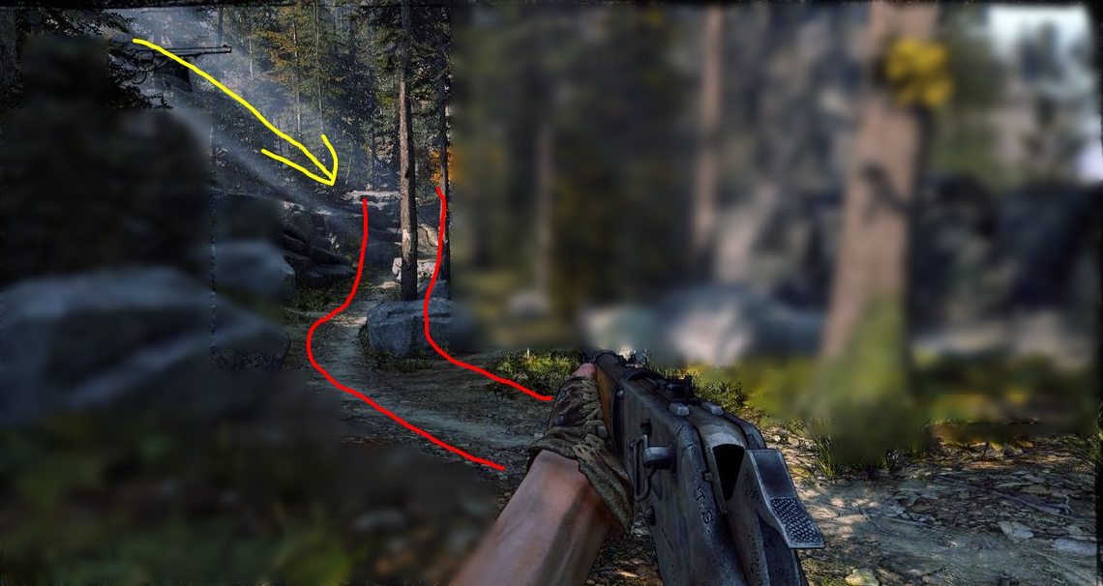

Figure How game gives hints to player through light and game environment

Game systems are set by the core mechanics of the game and what is needed to make the player engage in an immersive experience.

### 2.1.2 Education

The new minister of education has made a huge plan for the reform of education in Egypt. After 22 years of using the same system at public schools the new minister is set to change the curricula, examinations’ format, and the methods of educating students. This new system will render private tutors useless and give more room for students to research and learn by themselves in whichever topic they choose. Also, the introduction of the use of handheld devices [1] to students and teachers alike, will be more time-efficient for teachers to grade tests, students will be capable of doing more research, watch educational videos, also they will do online exams which will eliminate the need for papers and pens. Both sides will be better equipped to use modern technology and online applications.



Figure Tablet used by Egyptian students [1]

Higher education in Egypt is underfunded and inefficient to say the least. The political issues and increasing extremism and violence made university campuses unsafe in the past few years. Public universities encountered many protests causing even more conflict and unsettlements. The biggest problem that public universities face is the outdated curricula and graduates not finding work that suits their studies.

### 2.1.3 STEM

STEM Education system is based on four disciplines: Science, Technology, Engineering and mathematics. This system uses the four topics as interrelated topics rather than teaching each of them as a separate subject. While integrating them to real-life applications and practical experiments. With the increasing demand for computing related jobs i.e. data science and information technology, the education must take a step to provide a suitable workforce for the rapidly changing work field.

## 2.2 Previous Work

### 2.2.1

### 2.2.2

### 2.2.3

# Chapter 3: Project planning & monitoring

## 3.1 Requirements

We will use unreal engine and assets from epic games store and specially made assets to make our proposed game.

### 3.1.1 Functional Requirements

* Giving the player pedagogical content in a simplified interactive way.
* The player must finish all the levels or missions.

### 3.1.2 Non-Functional Requirements

* A desktop computer capable of running the game (specific specifications to be disclosed after the game is done)
* A controller or keyboard and mouse

## 3.2 Monitoring

# References

[1] *Business/Economy*. (2012, April 28). Retrieved from AhramOnline: http://english.ahram.org.eg/NewsContent/3/12/40362/Business/Economy/Egypt-authorities-to-supply-,-tablet-PCs-to-studen.aspx